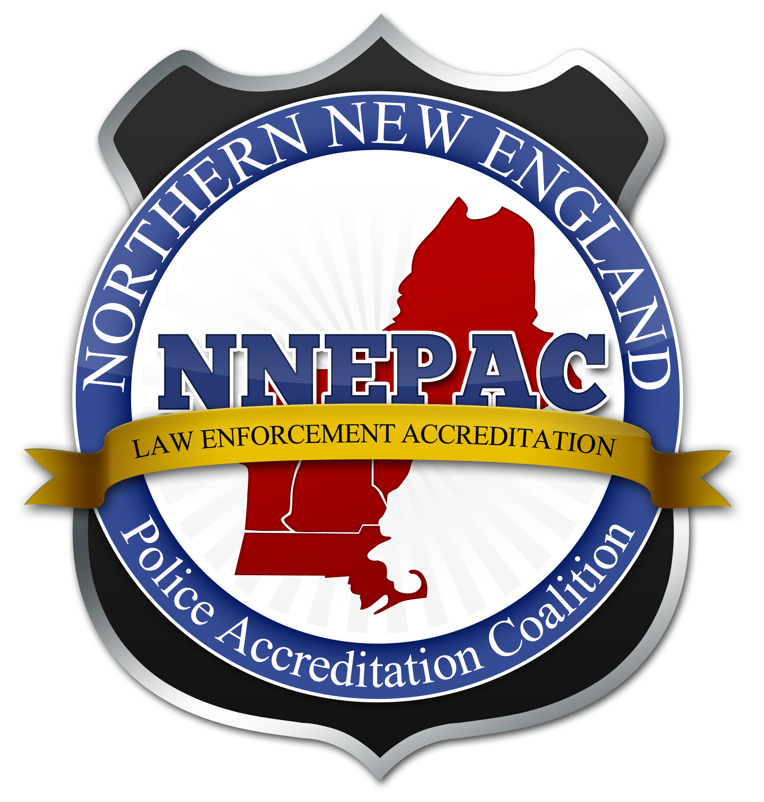

Northern New England Police Accreditation Coalition

Membership Application and Dues Invoice: 2017

Department Name
Mailing Address
City State Zip Code
Telephone: Fax:
E-mail:
Chief Executive Officer: Accreditation Mgr:
Number of Full Time Employees (agency size is based upon CALEA 5th Edition):
A: 1-24 B: 25-74 C: 75-299 D: 300+

Please indicate the interests of your agency with regard to the accreditation process (Check all that apply)
We would like to achieve CALEA Accreditation.
Our agency has financially committed to the process and paid application fee (“under contract”).
We are actively involved in self-assessment in the CALEA process.
We have achieved CALEA Accreditation.
Membership Type (Check only one)
Voting Member: NH, VT, ME, or MA Law Enforcement Agency (Annual dues @ $50.00)
Associate Member: Other Law Enforcement Agency or any governmental agency (Annual dues @ $50.00)
Honorary Member: Must be granted according to NNEPAC by-law qualifications (No dues)

Tax ID #35-2456677 Non-profit business league – 501C-6
Please make checks payable to "NNEPAC" and remit payment along with this form to:
Sergeant Mark Collopy
Dover Police Department
46 Chestnut St.
Dover, NH 03820

